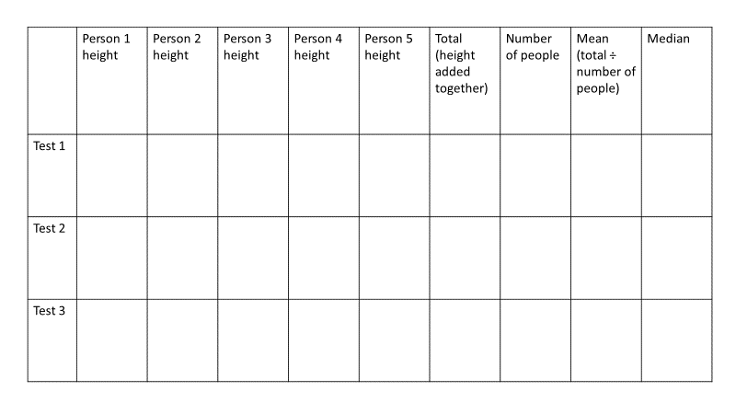

Ordered data
Test 1:
Test 2:
Test 3:
Ordered data
Test 1:
Test 2:
Test 3:

